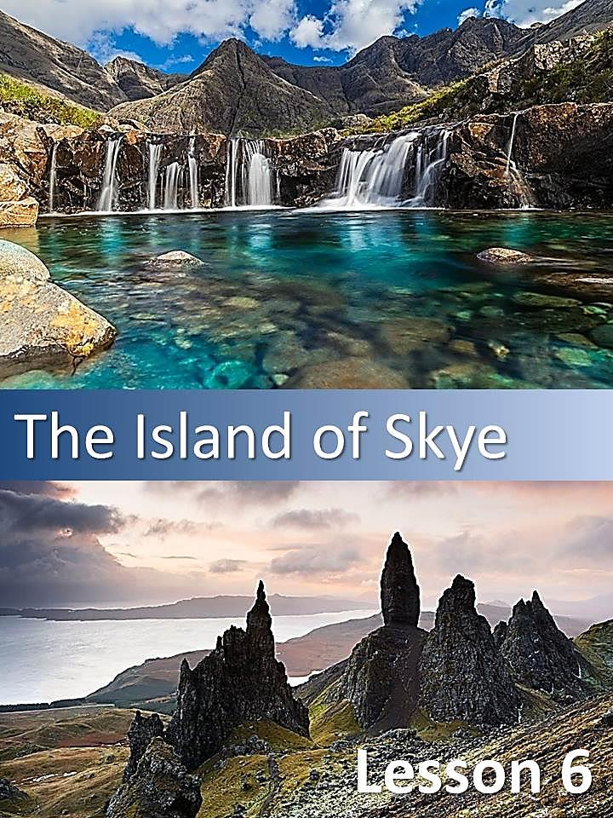

* 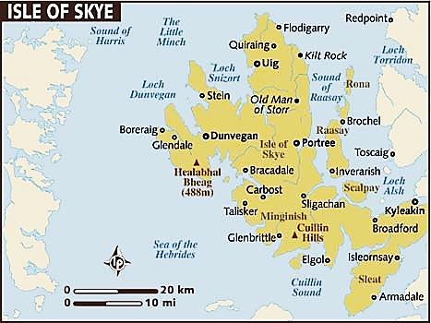Answer the following questions in Spanish.

1. Which countries make up the United Kingdom?
2. What is Scotland famous for?
3. What do you usually do when you go on holiday?

* Use your own words to explain the following phrases:

|  |  |
| --- | --- |
| The island of Skye **stands just** a few hundred meters off the coast of Western Scotland |  |
| The island's peninsulas |  |
| The recognition and appreciation of this living heritage |  |
| The legendary home of warrior woman |  |

*  Read the following text and make a map of it (use a sheet of paper).

### The Island of Skye: a Scottish Paradise

The island of Skye stands just a few hundred meters off the coast of Western Scotland and it is one of the most beautiful parts of the British Isles. In the summer it is bathed in sunshine, and in the winter it is covered in mists. There is mystery in its hills and valleys, and a strange, almost dream-like beauty. Skye has recently been voted the world's favourite island. It has been chosen as the 4th best island in the world by National Geographic magazine.

Skye is the largest and most northerly large island in the Inner Hebrides of Scotland. The island's peninsulas radiate from a mountainous centre which is dominated by the Cuillins, the rocky slopes of which provide some of the most dramatic mountain scenery in the country.

The area of Skye and Lochalsh can be seen as a microcosm of Highland life. It is shaped by national events such as the battles at Culloden in 1745. The twentieth century brought dramatic changes to the island, many families were affected by emigration, wars and urbanization. However, the way of life and integrity of traditional values in the community have remained strong.

The recognition and appreciation of this living heritage is still held very strongly today enriching much of the highland spirit, there are continuing traditions, work, art, and music. Dualchas, Skye & Lochalsh Museums Service has been formed because of the need to preserve a variety of archives, artefacts, maps, prints and paintings, postcards, antiquarian books and photographs. Skye and Lochalsh sites and monuments records are also held in these museums. Archaeological surveys and current information files on people, places and social history which are pertinent to the area have also been added to the museums´collections.

Skye has a rich heritage of ancient monuments from this period. Dunvegan Castle has been the seat of Clan MacLeod since the 13th century. It contains the Fairy Flag and the castle is reputed to have been inhabited by a single family for longer than any other house in Scotland. The 18th-century Armadale Castle was once the home of Clan Donald of Sleat, then it was abandoned as a residence but now it hosts the Clan Donald Centre. Nearby are the ruins of two more MacDonald strongholds, Knock Castle, and Dunscaith Castle. This is the legendary home of warrior woman, martial arts instructor and Queen Scáthach. She is especially associated with the Isle of Skye, where her residence Dun Sgathaich" (Fortress of Shadows) is located. She is called "the Shadow" and "Warrior Maid". Caisteal Maol was built in the late 15th century near Kyleakin and was once a seat of Clan MacKinnon. Now it is in ruin.

There are many trips to do in Skye. In the classic trip from Elgol visitors are taken to the steps of Loch Coruisk in the heart of the magnificent Cuillins, from here tourist can hike out in the footsteps of a historic tradition. Whale and dolphin spotting and observing seabird colonies are also offered. For the more energetic visitor there is the chance to get out and explore ashore in remote parts of the island. Boat trips to seal colonies are taken by tourists who want to see these big dark eyed mammals. Another way to really bring your visit to life is to book a trip with one of the regions tour guides. Personalised tours can be taken at your convenience and will be illustrated with a wealth of local knowledge and a few colourful legends. Speciality tours are also offered by local rangers, significant sites will be visited with their expert guidance. So live, love, learn Skye!

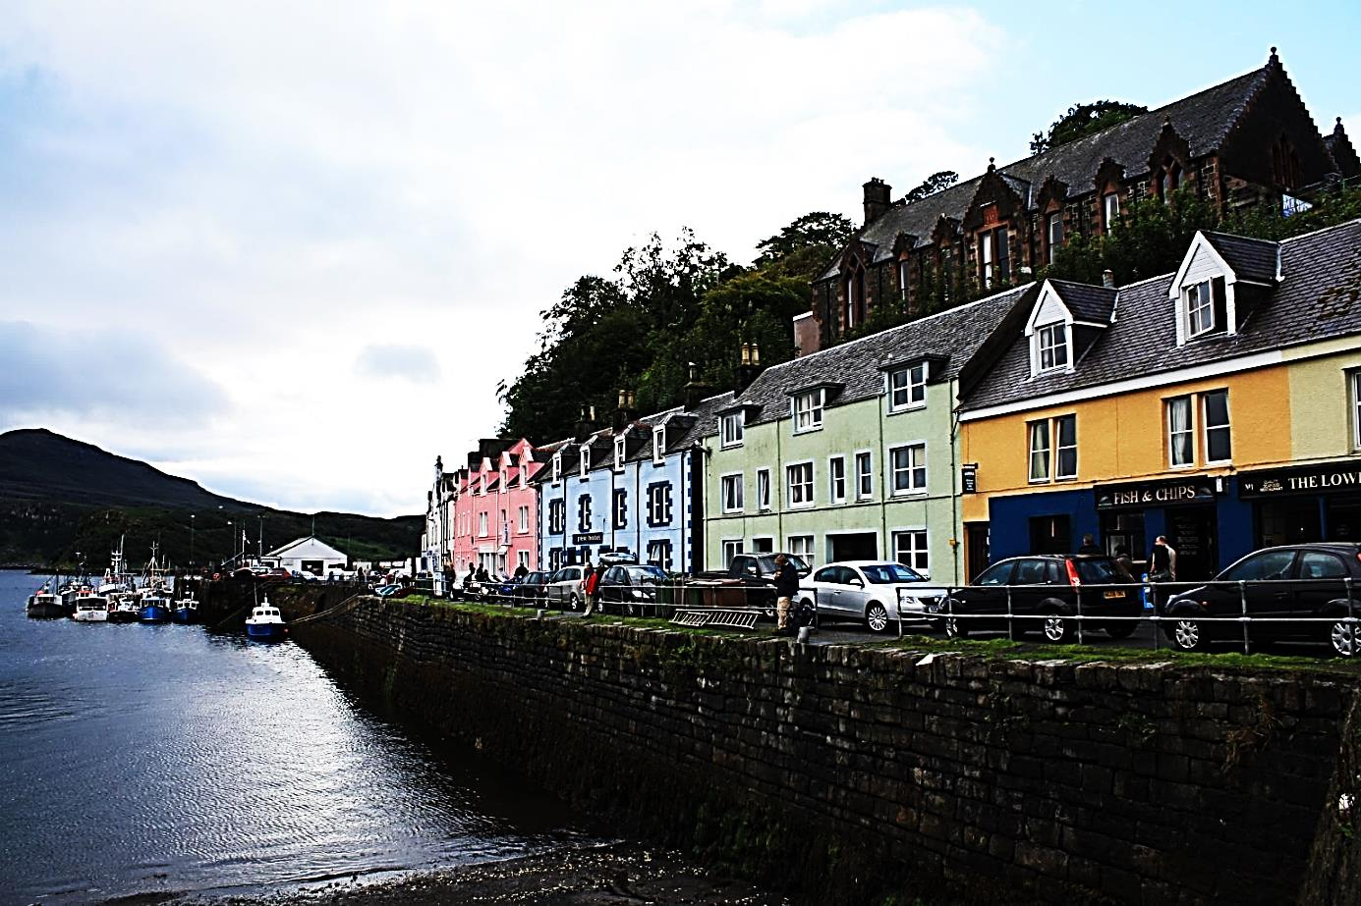

* Complete the table with key words from the text.

|  |  |
| --- | --- |
|  |  |
|  |  |

* Complete the table with cognates from the text.

|  |  |  |
| --- | --- | --- |
|  |  |  |
|  |  |  |

* Write the main idea of the text IN SPANISH.

The **main idea** is the most important part of a story.

* TRUE or FALSE? Justify the false statements.

|  | **True** | **False** | **Justification** |
| --- | --- | --- | --- |
| Skye is located in the south of the UK (United Kingdom). |  |  |  |
| It is a very inhospitable place. |  |  |  |
| Tourists have many places to visit there. |  |  |  |
| History lovers can enjoy a visit to Skye. |  |  |  |
| Tropical birds can be seen on the coast. |  |  |  |

#### REVISION TASK MC900404011[1]

* Complete the following table with information from the text.

|  |  |
| --- | --- |
| **Adjective** |  |
| **Adverb** |  |
| **Definite article** |  |
| **Cognate** |  |
| **Connector** |  |
| **Indefinite article** |  |
| **Imperative** |  |
| **Modal verb** |  |
| **Noun-noun** |  |
| **Possessive case** |  |
| **Present Continuous** |  |
| **Simple Past** |  |
| **Simple Present** |  |
| **Superlative adjective** |  |
| **Relative clauses** |  |

#### MC900404011[1]PASSIVE VOICE

##### ¿Cuál es la diferencia entre la Voz Activa y la Voz Pasiva?

La voz pasiva se utiliza para poner el foco en la acción. No es importante o conocido quién o qué realiza la acción sino lo que sucedió.

|  |  |  |  |
| --- | --- | --- | --- |
| ***E.g.*** | *My car was stolen.* | Mi auto fue robado. | **Ej.** |

En el ejemplo anterior el foco de atención está en el hecho que mi auto fue robado, no sé quién lo hizo.

Algunas veces un ejemplo en voz pasiva es más formal que en voz activa, como lo muestra el siguiente ejemplo:

|  |  |  |  |
| --- | --- | --- | --- |
| ***E.g.*** | *A mistake was made* | Un error fue cometido / Se cometió un error. | **Ej.** |

En este caso, ponemos el foco de atención en el hecho de que se cometió un error, pero sin culpar a nadie (ej.: *You have made a mistake* / Vos cometiste un error; Vos te equivocaste.).

| **Verbal Tense** | **Active Voice** | **Passive Voice** |
| --- | --- | --- |
| Simple Present | Paul writes a poem | A poem is written by Paul |
| Present Continuous | Paul is writing a poem | A poem is being written by Paul. |
| Present Perfect | Paul has written a poem. | A poem has been written by Paul. |
| Simple Past | Paul wrote a poem. | A poem was written by Paul. |
| Past Continuous | Paul was writing a poem. | A poem was being written by Paul. |
| Future Simple | Paul will write a poem | A poem will be written by Paul. |
| Modal verbs | Paul can write a poem.  Paul may write a poem.  Paul must write a poem.  Paul should /ought to write a poem. | A poem can be written by Paul.  A poem may be written by Paul.  A poem must be written by Paul.  A poem should/ ought to be written by Paul. |

##### El agente en las oraciones en voz pasiva

La mayoría de las oraciones en voz pasiva en inglés no incluyen el agente, construcción que indica quién o qué realiza la acción. Sin embargo el agente existe y se señala a través de una frase preposicional que comienza con la preposición ***by***.

|  |  |
| --- | --- |
| A poem is written | **by Paul**. |
|  | ***agente*** |

**Más ejemplos:**

* 1. My car **was stolen** by someone.
  2. A decision **has been made** by the group.
  3. Much tobacco **is grown** in Eastern Europe by farmers.
  4. A new president **has been elected** by the voters.
  5. Both French and English **are spoken** in Canada by the populace.

Si bien en estos ejemplos figura un agente, éste es innecesario porque no aporta ninguna información relevante.

**Utilizamos el agente cuando:**

1. Es un nombre propio que indica un artista, un pintor, un descubridor, etc.
   1. The Mona Lisa **was painted** by Leonardo da Vinci.
   2. The Americas **were discovered** by Christopher Columbus.
   3. The first computer **was built** by Charles Babbage.
   4. Rubber **was** first **vulcanized** by Charles Goodyear.
2. Es una frase nominal que expresa nueva información importante de señalar.
   1. These works of art **were** all **produced** by a woman.
   2. The corner store **was robbed** by a masked gunman.
3. Es un sustantivo inanimado de actuación/aparición inesperada:
   1. Thirteen people **were injured** by a tornado in Florida.
   2. All the lights in this building **are controlled** by computers.

* Read the article “The Island of Skye: a Scottish Paradise” again and identify examples of Passive Voice, complete the following chart.

| **Verbal Tense** | **Example** |
| --- | --- |
| Simple Present 1 | *Six interactive modules are presented to the children* |
| Simple Present 2 |  |
| Simple Past |  |
| Present Perfect |  |
| Modal Verb 1 |  |
| Modal Verb 2 |  |

* Read the article once more and identify examples of Passive Voice in which an agent if present. Explain its use.

| **Example** | **Use** |
| --- | --- |
|  |  |
|  |  |
|  |  |
|  |  |

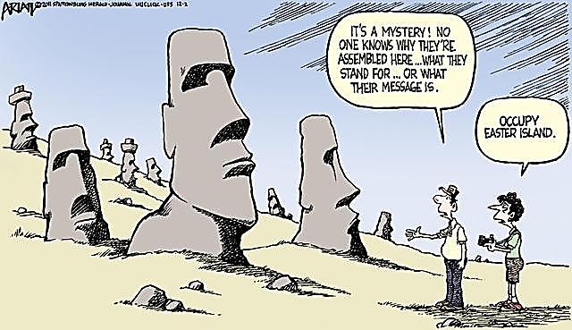

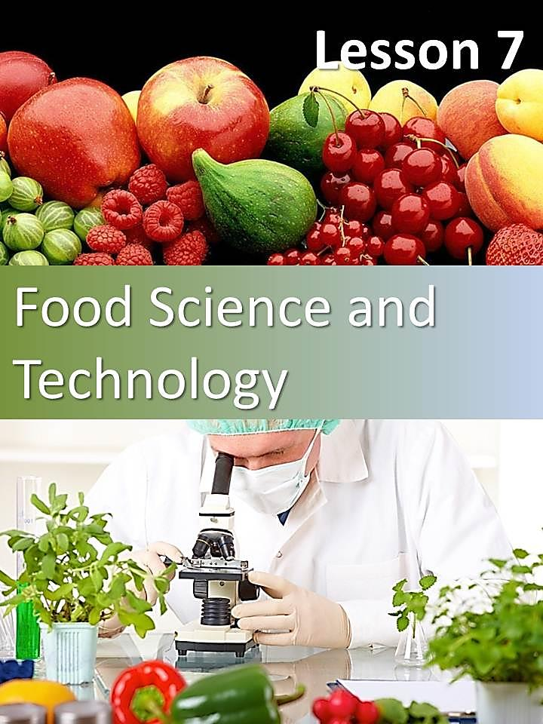

# Lesson 7

## Food Science and Technology

* Answer the following questions in Spanish.

1. What do you think food scientist study?
2. Why is it important to know about what you eat?
3. Do you have a healthy diet?
4. How can food be bad for your health?

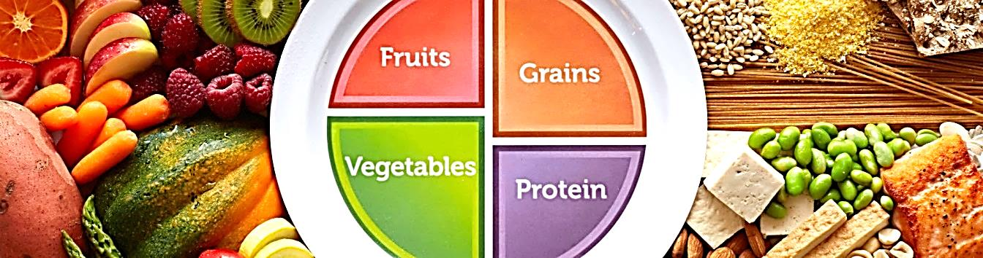

* Read the article carefully and put the following questions in the correct place.

### Food Science and Technology

|  |
| --- |
| What are trans fats and what do they do?  Why were trans fats used in the first place?  What Are Trans Fats?  What have companies been doing so far?  What happens when you take them out? |

**Food Science**

Food science draws from many disciplines such as biology, chemical engineering, and biochemistry in an attempt to better understand food processes and **ultimately** improve food products for the general public. As the stewards of the field, food scientists study the physical, microbiological, and chemical makeup of food. By applying their findings, they are responsible for developing the safe, nutritious foods and innovative packaging that line supermarket shelves everywhere.

**Food Technology**

The food any **individual** consumes on a daily basis is the result of extensive food research, which consists of a systematic investigation into a variety of foods’ properties and compositions. After the initial stages of research and development comes the mass production of food products using principles of food technology. All of these interrelated fields contribute to the food industry, which is the largest manufacturing industry in the United States.

**1.**

The U.S. Food and Drug Administration (FDA) recently announced that it is taking steps to further reduce artificial trans fat from processed food. The following Q&A (questions and answers) with Mary Ellen Camire, who is the President-Elect of the Institute of Food Technologists, explains what consumers need to know about trans fat.

**2.**

A: Trans fats are part of partially hydrogenated fats used to help stabilize foods for storage and also create the desired texture and baking properties of foods. For **instance**: providing the creaminess in icings and stability in cookies.

**3.**

A: If you use vegetable oil when you make a cookie, the cookie tends to be runny and flat. If you want a nice fluffy cookie, it is **advised** to use a solid fat. The problem is we were trying to get away from solid fats because they contain saturated fats.

**4.**

A: Originally, they were designed to help make food products more healthful as an alternative to saturated fats which we know are not good for cardiovascular disease. Food companies began introducing them into more products, because they help contribute to foods being more stable and lasting longer, and you reduce food waste, so they were very popular.

As people began to realize that the process to transform the oils into fats produced some of these trans fatty acids, they became concerned about the role of these acids in health because they are not found commonly in nature. Over the years there has been more evidence suggesting that these trans fatty acids may be bad for cardiovascular health as well.

**5.**

A: So far food companies have been switching out and using more saturated forms of fat: butter, cocoa fat, palm oil, other sources that tend to be more stable and have more of a solid nature. In some cases, they can completely reformulate the product.

If you are interested in this topic, you will find the following site useful: <http://www.ift.org/>

* Read the article again and answer the following questions.

1. What do food scientists study?
2. Is food the biggest industry in the United States?
3. What did the FDA announce?
4. Define trans fats.
5. Are trans fats good for your health? Why / Why not?

#### MC900404011[1]RELATIVE CLAUSES

* Now look at the following example from the text.
* Recognize the relative clause.
* Underline the relative pronoun.
* Translate the sentence into Spanish.

|  |  |
| --- | --- |
| **Example** | **Spanish** |
| … the result of extensive food research, which consists of a systematic investigation… |  |
|  |
|  |
|  |

Usamos cláusulas o proposiciones relativas para brindar información adicional acerca de algo sin usar otra oración. Al combinar oraciones con una clausula relativa, el texto suena más fluido y se evita la repetición.

| **Relative Pronoun** | **Meaning** | **Example** |
| --- | --- | --- |
| WHO  THAT | QUIÉN  QUIENES | The historians **who** (that) date the end of Ancient Times in the year 476 AD consider the fall of the Western Roman Empire. |
| WHICH  THAT | QUÉ  CÚAL | Sumerian Cuneiform, **which** (that) is the oldest form of writing, developed in the Middle East. |
| WHOSE | CUYO | Felipe Pigna is a historian **whose** books have become best- sellers. |

|  |  |  |
| --- | --- | --- |
| **Relative Adverb** | **Meaning** | **Example** |
| WHERE | DÓNDE | The place **where** the Homo Sapiens evolves is Africa. |
| WHEN | CUANDO | The year **when** I was born was very cold |
| WHY | POR el/la CUAL | That is the reason **why** we met him |

* Recognize three examples of relative clauses from the text and underline the relative pronoun.

1.

2.

3.

#### http://www.literautas.com/es/blog/wp-content/uploads/eye-magnifying-glass-book.gifCOGNATES AND FALSE COGNATES

* Recognize as many examples of cognates as you can. Then, say what they mean in Spanish.

| **Cognate** | **Spanish** |
| --- | --- |
|  |  |
|  |  |
|  |  |
|  |  |
|  |  |
|  |  |
|  |  |
|  |  |
|  |  |
|  |  |

El **cognado** es el término que se utiliza para denominar a una palabra de una lengua “X” que guarda cierto parecido y comparte significado con una palabra de una lengua “Y”. Por ejemplo, *encyclopaedia* (en inglés) es un cognado de *enciclopedia* (en español).

| **Palabra en inglés** | **Significado en español** |
| --- | --- |
| music | música |
| problem | problema |
| dollar | dólar |

Se denomina **false cognate** o **false friend** (falso cognado) a dos palabras en distintos idiomas, que por la forma en que se escribe o se pronuncia, se parece mucho a otra palabra en el otro idioma, pero con otro significado.

|  |  |  |
| --- | --- | --- |
| **Falsos cognados** | **Significado en inglés** | **Significado en español** |
| **Carpet** vs **Carpeta** | **Carpet:** alfombra. | **Carpeta:** folder, file, portfolio, briefcase, table cloth. |
| **Exit** vs **Éxito** | **Exit:** salida. | **Éxito:** success. |

* Look at the following words in bold from the text. What do you think they mean? Check with a dictionary.

ultimately:

individual:

instance:

adviced:

* Are they cognates or false cognates?